**Sensor and measurement pratice**

**Practice report – week 1 – group** **8** **NGUYỄN TIẾN NHẬT**

**Mssv:1613133**

**Chapter 8: V/F AND F/V CONVERTERS**

**I)EXPERIMENTS AND RECORDS**

**1)VFC converter**

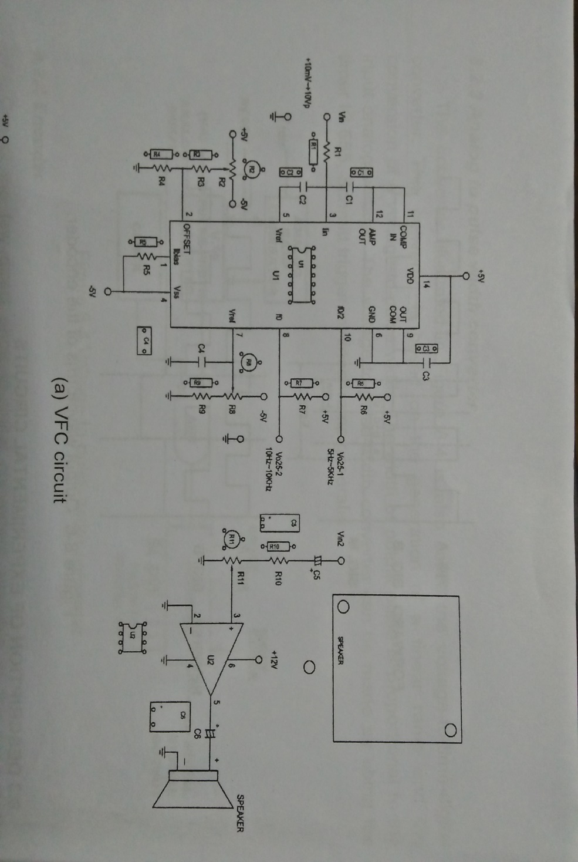

DO the experiment with VFC circuit modules KL-64010 and then complete the providing data table and caculate the output linearity.

